Chicken Pot Pie
Key is cooking in a cast-iron!

Notes: 7/16/23
Added green onion, left out peas. 3 carrots. ½ yellow onion, three stems green onions, 2 celery stalks. Used chicken bone broth. Used vermouth instead of white wine. Cooked entire thing in my cast iron, added chicken skin, as well. Just laid puff pastry on at the end. Salt fat acid heat has another recipe here.
Kid verdict – good, but not great. Needed more salt. They wanted it creamier. It was a little too liquidy for my tastes. This is within spitting distance of formaggio’s.
YIELDS:
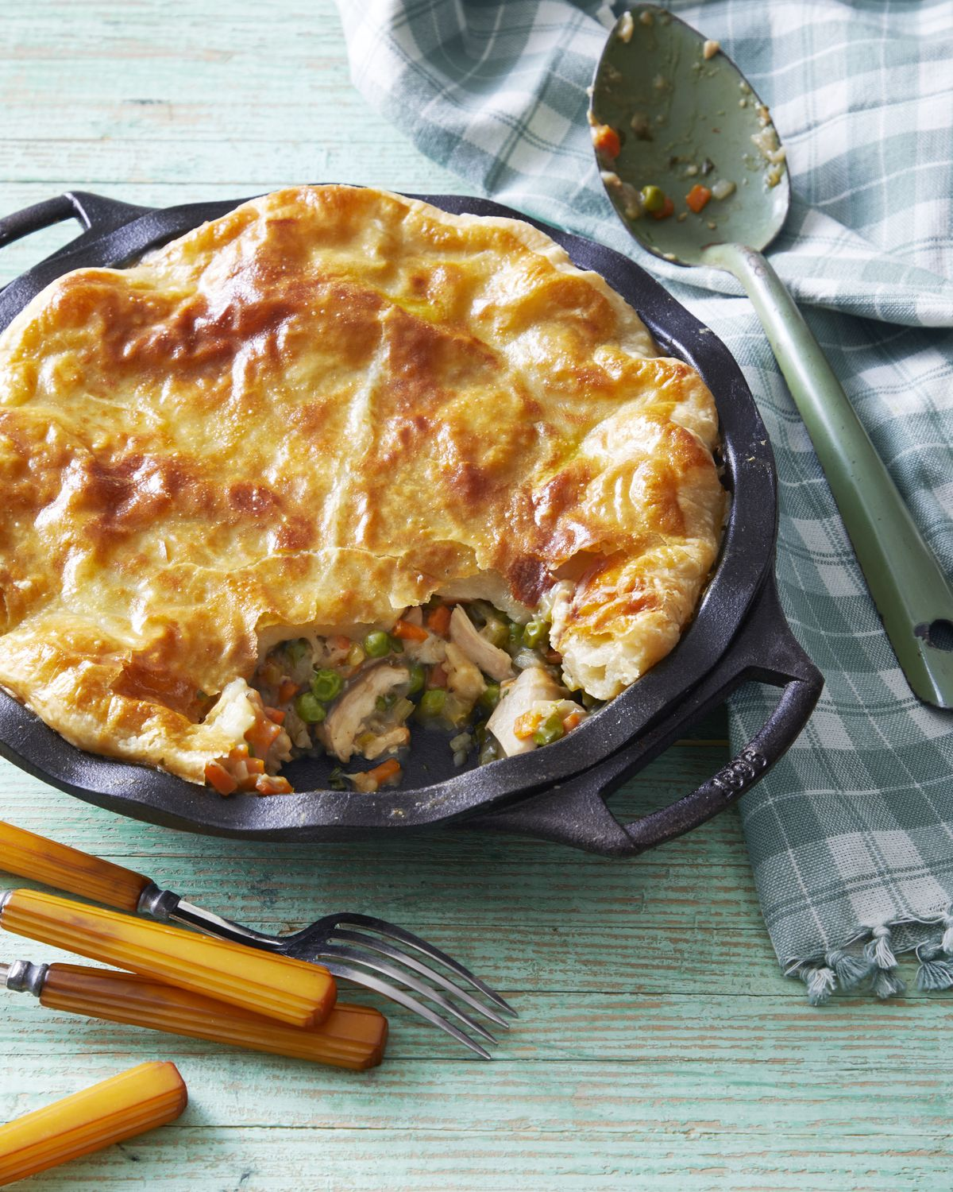
4 - 6 serving(s)
PREP TIME:
20 mins
TOTAL TIME:
45 mins

Ingredients
- 1 tbsp. olive oil
- 1 1/2 lb. bone-in, skin-on chicken thighs
- Kosher salt and freshly ground black pepper
- 1/2 yellow onion, chopped
- 2 carrots, chopped
- 2 stalks celery, chopped
- 1 tsp. fresh thyme
- 1/4 c. all-purpose flour
- 2 c. chicken stock
- 1/4 c. dry white wine
- 1 c. frozen peas
- 1/4 c. fresh flat-leaf parsley
- 1 (14-ounce) package all-butter puff pastry
- 1 large egg, beaten

Directions

Step 1
Preheat oven to 425°F. Heat a large cast-iron skillet over medium-high heat. Add oil. Season chicken with salt and pepper. Cook, skin sides down, until golden brown and crisp, 6 to 8 minutes. Flip chicken and transfer skillet to the oven. Cook, until the internal temperature of the thickest thigh registers 165°F on an instant-read thermometer, 12 to 14 minutes. Transfer to a cutting board. Discard skins and bones, and chop chicken.

Step 2
Place skillet over medium-high heat. Add onion, carrots, celery, and thyme. Season with salt and pepper. Cook, stirring occasionally, just until crisp-tender, 3 to 4 minutes. Add flour and cook, stirring, 30 seconds. Slowly stir in stock and wine. Bring to a boil. Reduce to a simmer and cook, stirring occasionally, until thickened, 4 to 6 minutes. Remove from heat. Stir in chicken, peas, and parsley.

Step 3
Cut puff pastry into a circle 1 inch larger than the outside rim of a cast-iron pie plate. (You may need to roll the dough on a lightly floured work surface to get it to size.) Place pie plate on a rimmed baking sheet. Transfer filling to pie plate and top with puff pastry; crimp edges. Brush puff pastry with egg. Bake, until golden brown, puffed, and cooked through, 20 to 25 minutes.

